

Logo as hyperlink for home

Movies

City(optional)

)

Sign in

Upcoming movies Images slider

Contact details

After click on movies-



Logo as hyperlink for home

Movies

City(optional)

)

Sign in

Contact details

All movies available (check on end date)

After clicking login – redirect to login page



Movies

Logo as hyperlink for home

City(optional)

)

Sign in

Contact details

Sign in

Login id:

Password:

LOGIN

new user? want to Register as 

After clicking in dropdown list on theater owner—



Movies

Logo as hyperlink for home

City(optional)

)

Sign in

Contact details

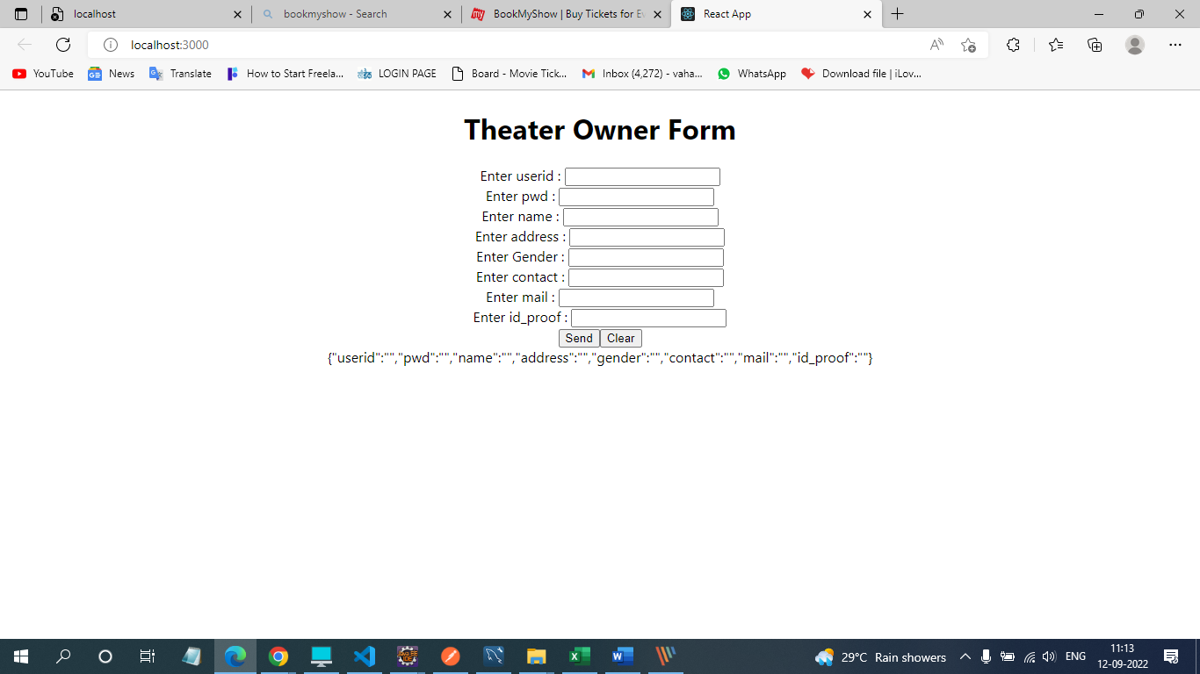

After clicking in dropdown list on customer owner—



Movies

Logo as hyperlink for home

City(optional)

)

Sign in

Contact details

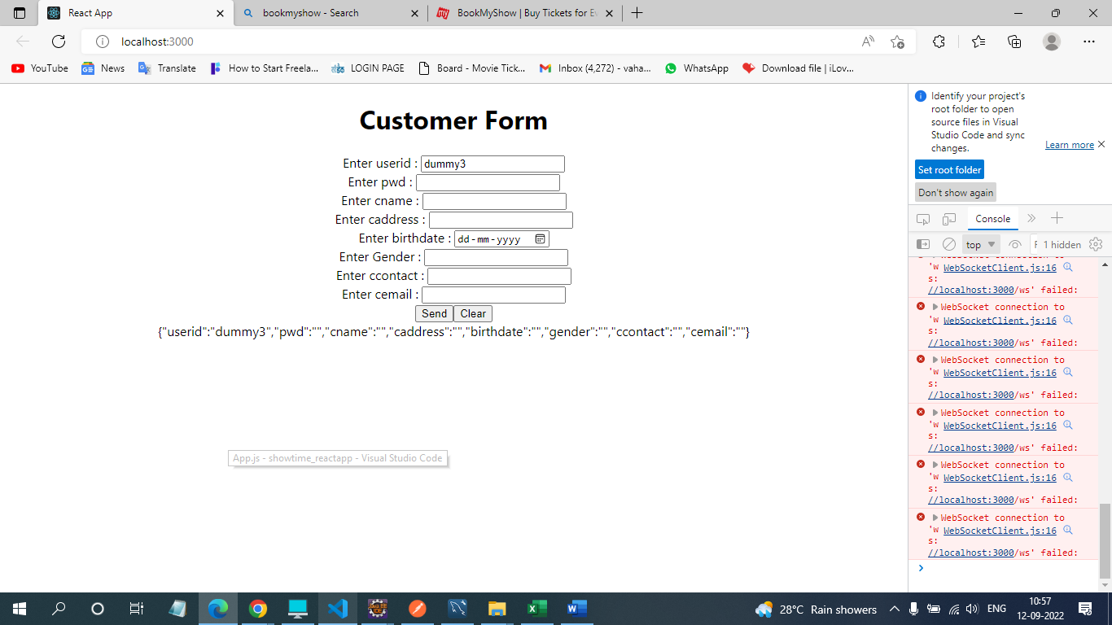

After successful admin login – redirect to admin ui page



Movies

Logo as hyperlink for home

City(optional)

)

Sign in

Contact details

Theater owner

Ads movies

verification

Oname idproof contact active status

Vishakha 789874 \*\*\*\*\*\*\* 0

verify

Oname idproof contact active status

Vishakha 789874 \*\*\*\*\*\*\* 1

remove

Movie registration form

After clicking login as theater owner ui-



owner name

Movies

Logo as hyperlink for home

City(optional)

)

Contact details

Add theaters

List of theater scrnno mid

1. Padma 1 1 allot movie slot remove movie from theater screen

2 2 allot movie slot remove movie from theater screen

1. Mukta 1 2 allot movie slot remove movie from theater screen

2 4 allot movie slot remove movie from theater screen

My Theaters

Add screen capacity

Add screen capacity

Add screen capacity

theater registration form

Tid scnid mid

After clicking login as customer login ui-



customer name

Movies

Logo as hyperlink for home

City(optional)

)

Contact details

theatre

List of movies

1. Bhramastra hindi 2D release date City dropdown

List of theater

1. Padma city name

shows

book

List of shows

1. Srceen no Date starttime endtime